Ways to Order  Phone – If you already know what you want & how many m2, then just give us a call and we can have your order ready in 1-3 days.  Email – for those that prefer to email, our email address is sales@instantgreen.co.nz  Online – Our website is at the bottom of the front page, you can order soil, mulch, seed & fertilizer on there, however not turf, as delivery costs depend on where you live.  In Store – Instant Green is located at 35 Ulyatt Road, Napier. Can be seen from the expressway. Pop in to discuss the best option for your lawn. |  | Look forward to hearing from you! |  |  | Re-doing your lawn?  - Here is a basic step-by-step guide to re-doing your home lawn.  Call:06 843 3330  www.instantgreen.co.nz

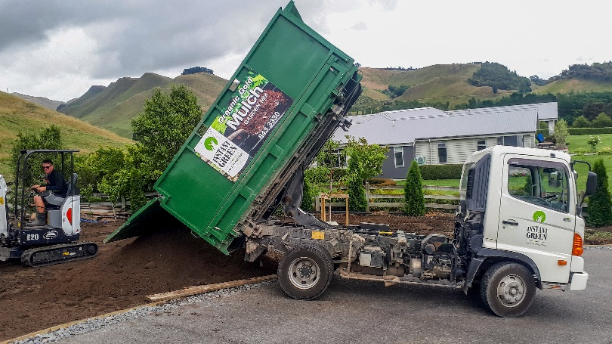  Existing Lawn  Remove/spray out the existing lawn, and ensure the area is level, with no slumps/stones. We can arrange someone to visit your site and quote, they will let you know if you need topsoil.  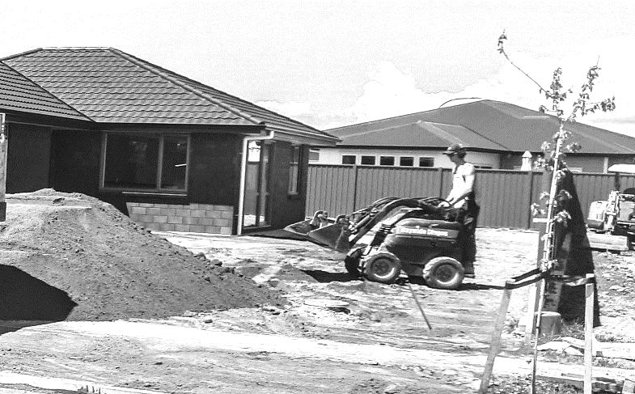  Preparation  Preparation involves spreading the new topsoil, ensuring the area is level and firm. Now is the time to install pop-ups if you are using them. In the preparation phase, we mainly sub-contract to locals, call us if you need assistance. | 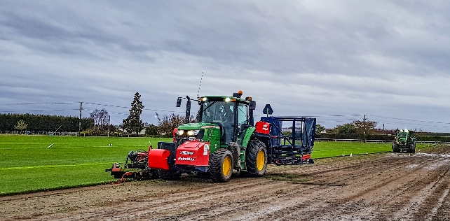  Ordering Your Lawn  Measure the area to find out how many m2 of Ready Lawn you need and order it 1-3 days before required, as we cut to order. Feel free to ask what lawn variety is best for your area. We recommend purchasing our “starter” fertilizer, which is put down before the lawn is installed.  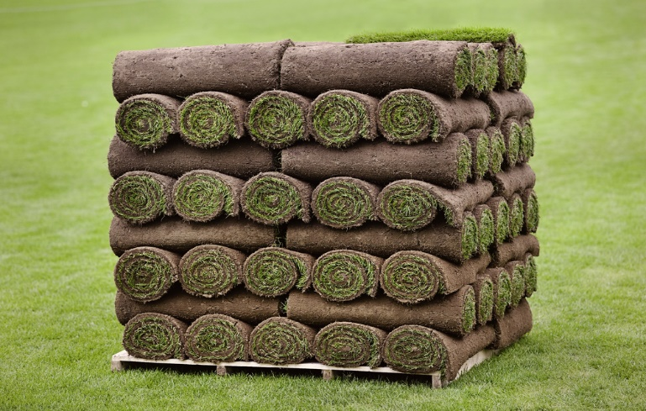  Collection / Delivery  Your lawn is now ready for collection. We have trailers available for you to borrow if local, otherwise delivery is extra. We can deliver Wellington – Auckland, please enquire. 1 Pallet takes 55m2 max. | Installation  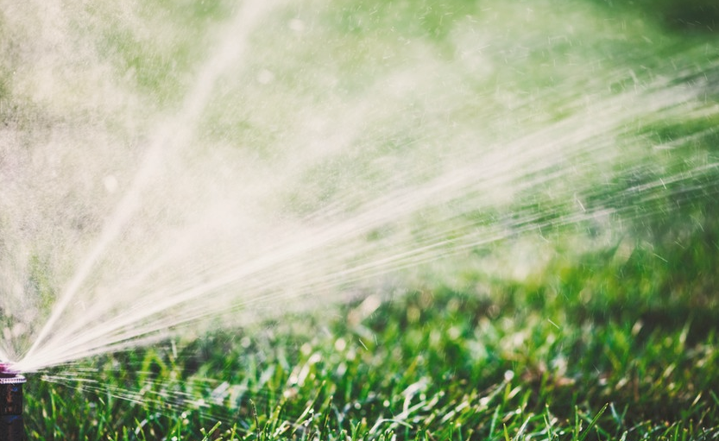  Installation involves a bit of man labor, which we can arrange for you if required, however this is easily done by yourself. Simply start one end/corner and roll outwards. For curved pavements etc., just simply cut & shape the turf with a knife and place where required.  Care & Maintenance  Care for your lawn is important over the first 3-4 weeks especially. Water it every day for 30mins in the morning or evening, this will help the rolls to bond and the roots to connect with the soil beneath. Only mow when the roots have fully connected with the soil. You can tell by trying to lift a corner. Keep pets off grass for first month ideally.

